**Visualizing Earth Quake Data Exploring Seismic Activity with Tableau**

**Problem Statement:**

ABC Company expands its global operations, it faces the challenge of understanding and mitigating potential risks associated with seismic activity in regions where it operates or plans to expand. The project 'Visualizing Earthquake Data: Exploring Seismic Activity with Tableau' aims to provide ABC Company with valuable insights into seismic patterns and trends worldwide. By leveraging Tableau's data visualization capabilities, the project seeks to analyze earthquake data sets to identify regions of heightened seismic activity and potential risk hotspots. Through interactive visualizations and in-depth analysis, ABC Company aims to enhance its risk assessment strategies, enabling proactive measures to safeguard its operations, infrastructure, and personnel in earthquake-prone areas. Additionally, by gaining a deeper understanding of seismic activity, ABC Company aims to strengthen its disaster preparedness plans, ensure business continuity, and reinforce its commitment to the safety and well-being of its employees and stakeholders across the globe.

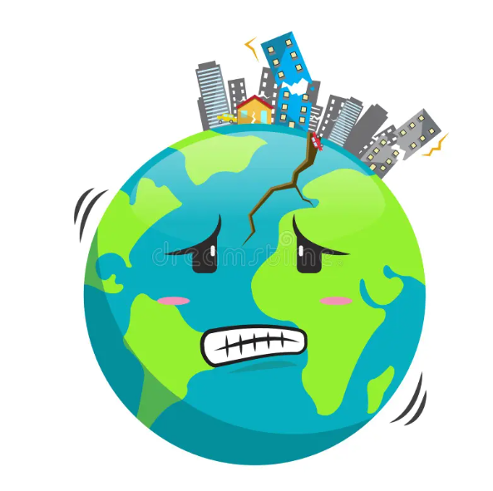

**Objective:**

An objective is a specific, measurable, and time-bound goal or target that an individual or organization aims to achieve. Objectives are typically set to guide actions and decision-making towards desired outcomes. They are often a part of broader goals and help to clarify what needs to be accomplished within a certain timeframe. Objectives should be realistic, achievable, and relevant to the overall mission or purpose, providing a clear direction for efforts and resources.

**Task:**

* The objective of this project is to visualize significant earthquakes over the past 100 years using Tableau, aiming to identify spatial and temporal patterns in seismic activity.
* Through interactive visualizations, we seek to gain insights into the distribution, frequency, and intensity of earthquakes to inform risk assessment and disaster preparedness efforts.

**Dataset**: [Link](https://drive.google.com/drive/u/0/folders/1W6B4IbriBfFU4_aKMUQM6dDoyzvhx_Qp)

**Solution Development Procedure:**

* In Tableau, the "Connect" option refers to the initial step in the data visualization process where users connect to various data sources to import data into Tableau for analysis and visualization.
* When you select the "Connect" option in Tableau, you are presented with a variety of data connection options.

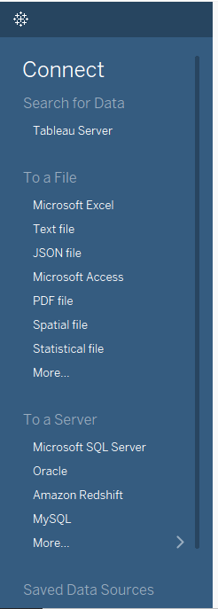

* Once you load the Dataset into the Tableau.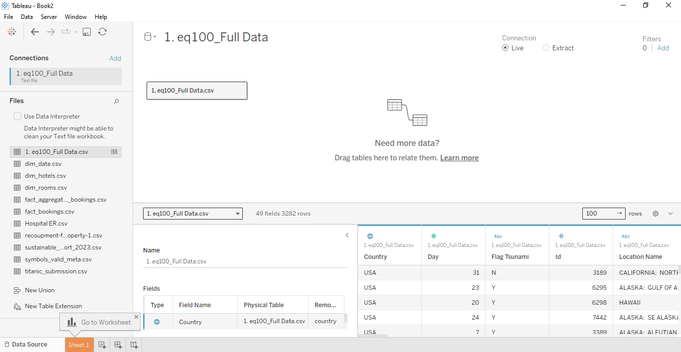
* Drag Year into the Columns and convert into discrete form.

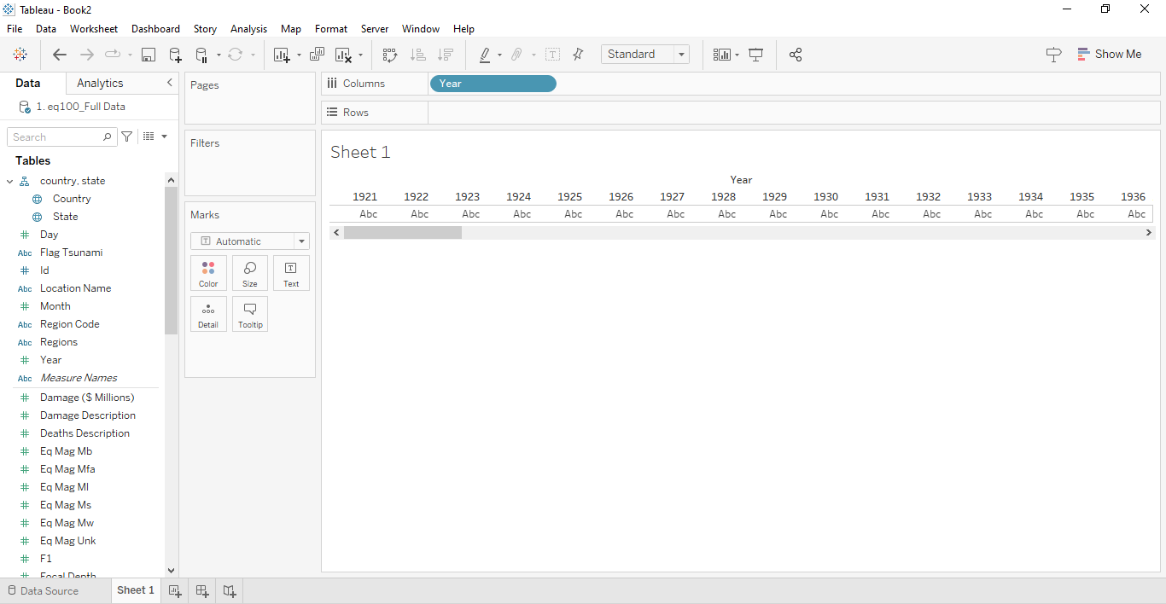

* Drag Magnitude into Rows.

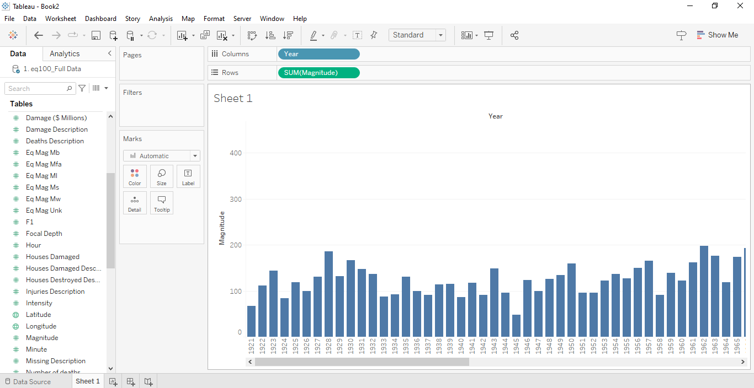

* Convert Bar graph to Shapes in Marks Card.

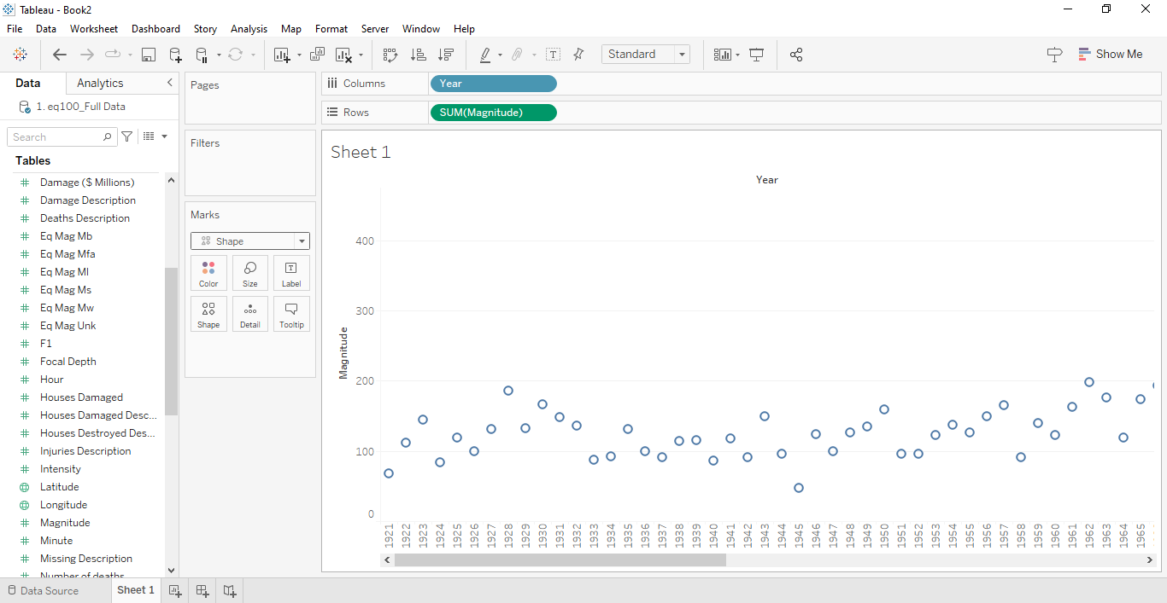

* Convert Sum of Magnitude to Maximum of Magnitude in rows.

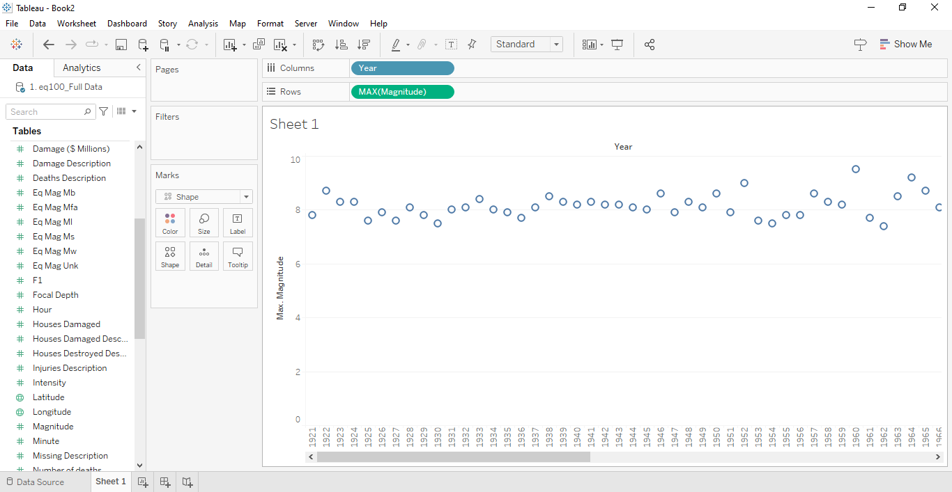

* To display the locations in visual , drag Location name into the label in Marks Card.

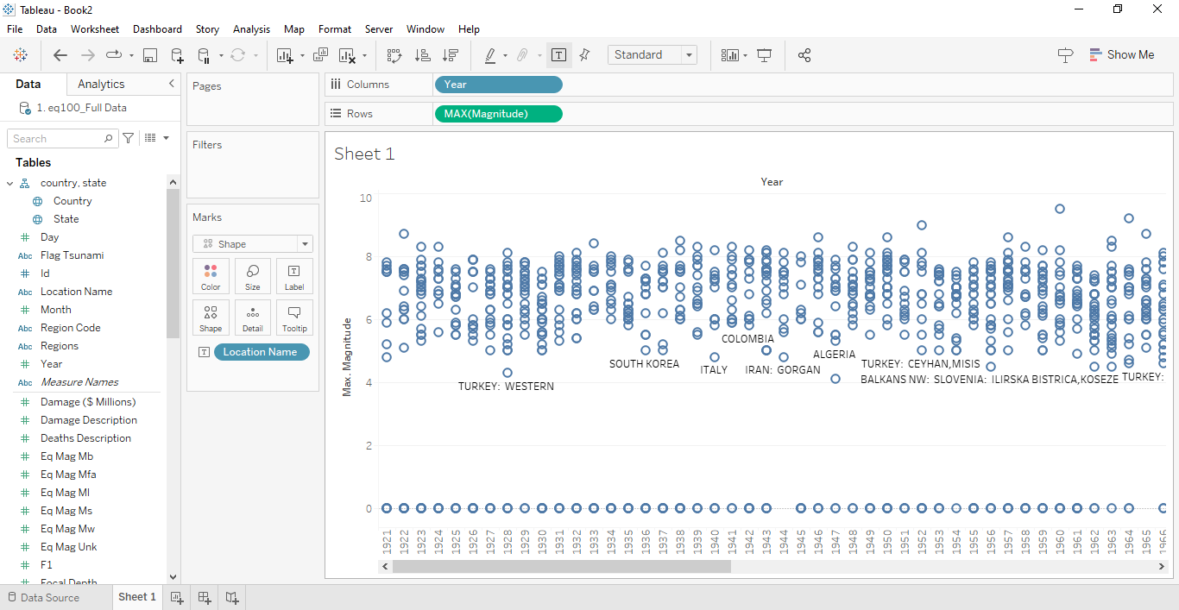

* Convert your Shape and drag Maximum of Magnitude into the size in marks card.

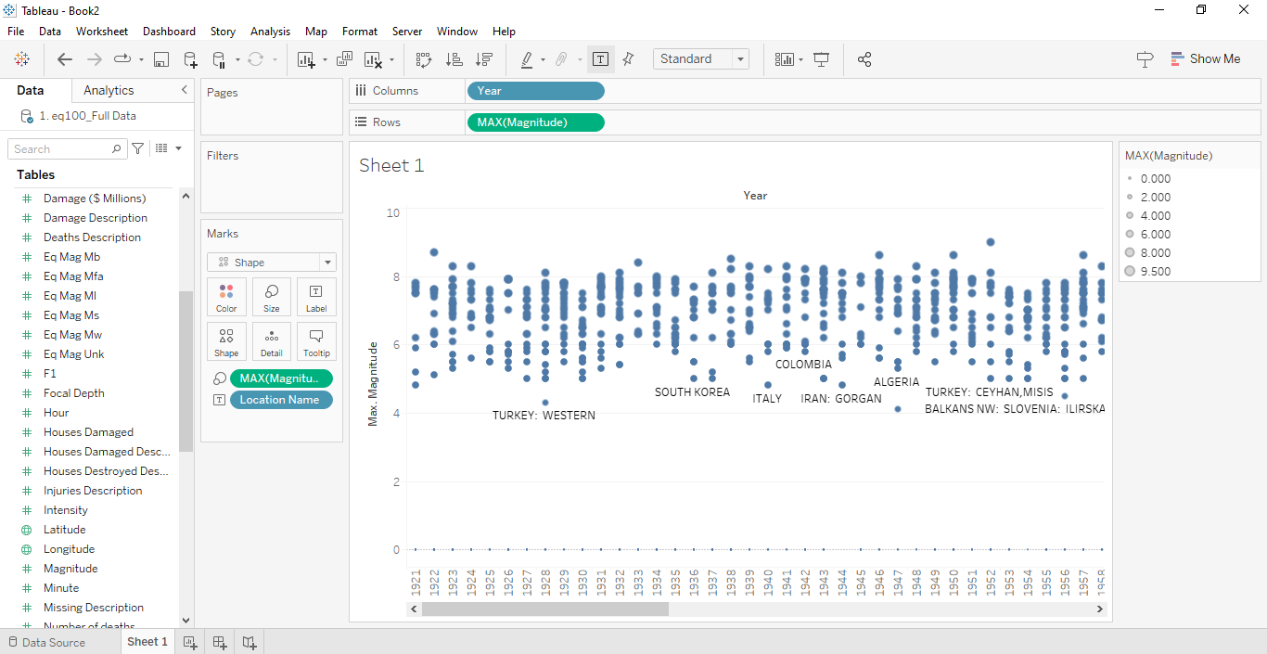

* To specify the Maximum of Magnitude in visual , drag Max of Magnitude into label in Marks Card.

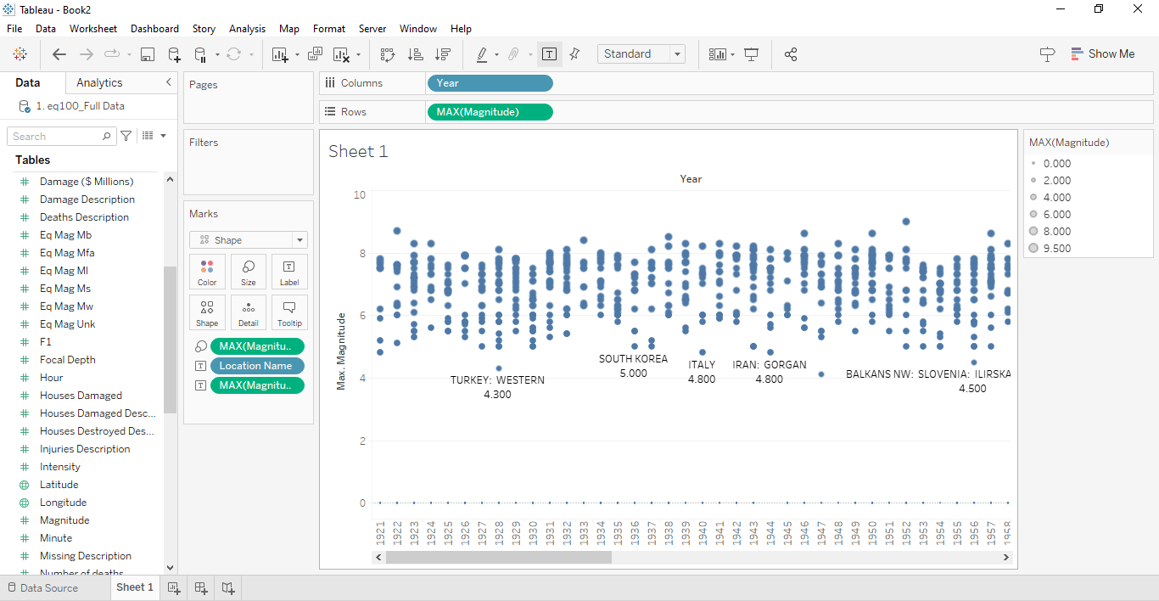

* Create Calculated fields such as Day of Occurrence and Time of Occurrence of Earthquakes.

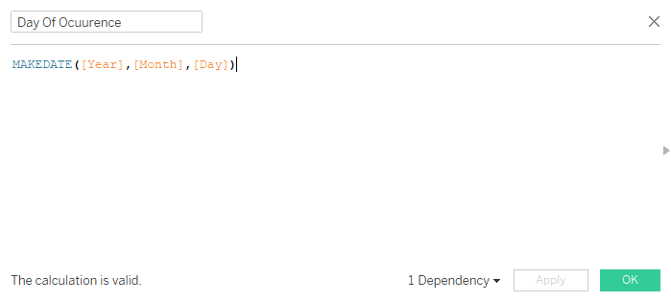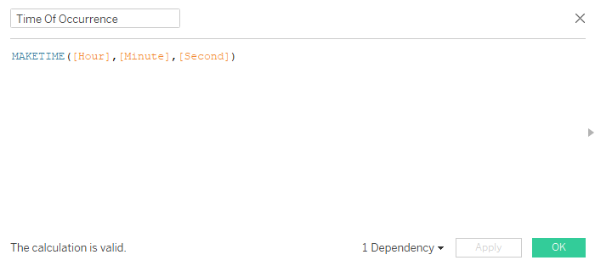

* Convert Day of Occurrence into Exact Date and format your Date as MM/DD/YYYY to display it on your visual by dragging it into label in marks card.

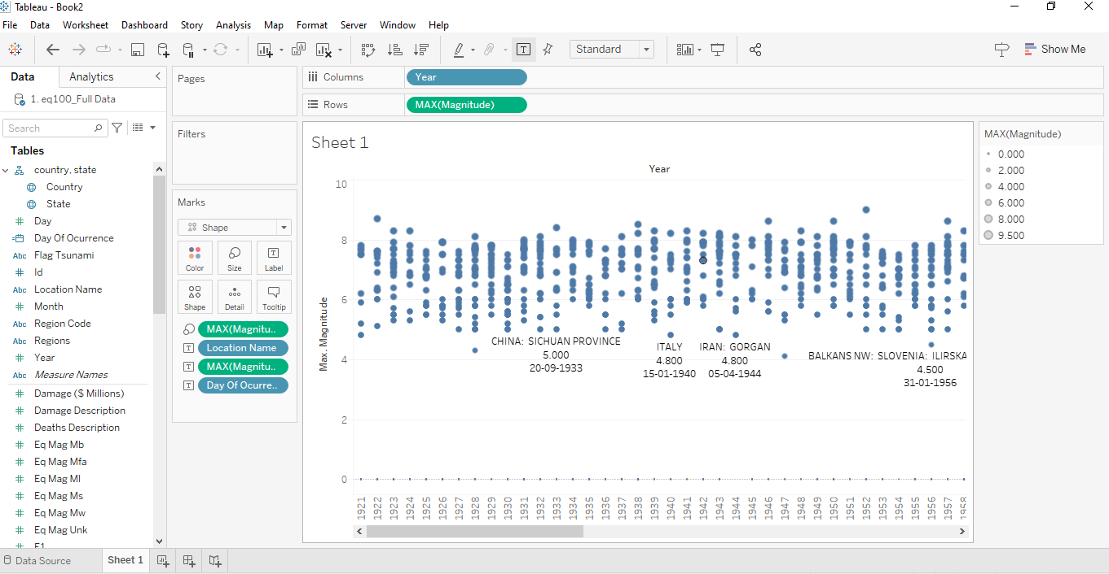

* Convert Time of Occurrence into Exact Time and format your Time as HH:MM:SS to display it on your visual by dragging it into label in marks card.

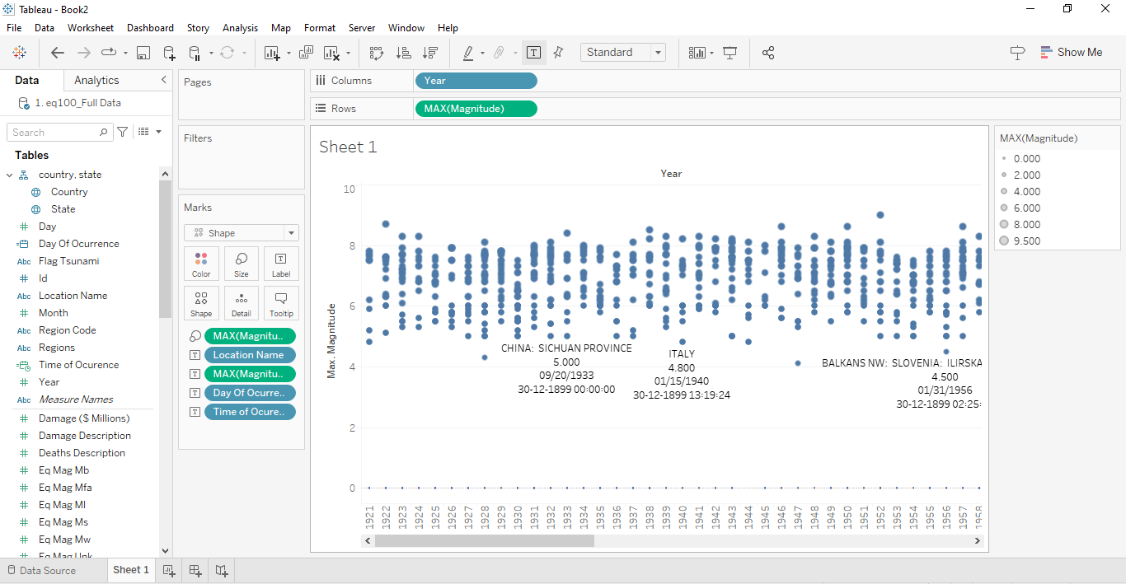

* Create a Calculated Field as Colour Ritcher to specify the colour of your visual and Drag into the Colour in Marks card.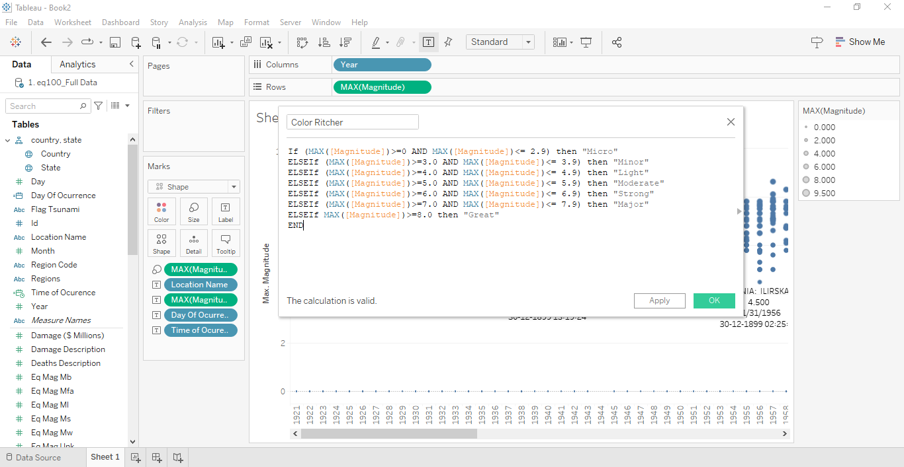

* Specify the title and Format your Visual Background, Shading and also choose different Colours for the Colour Ritcher i.e., Great , light , Minor , Micro , Major , Strong , Moderate.

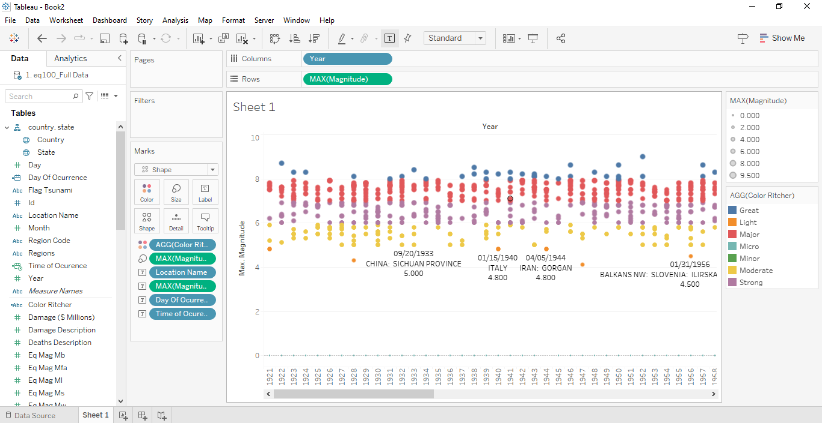

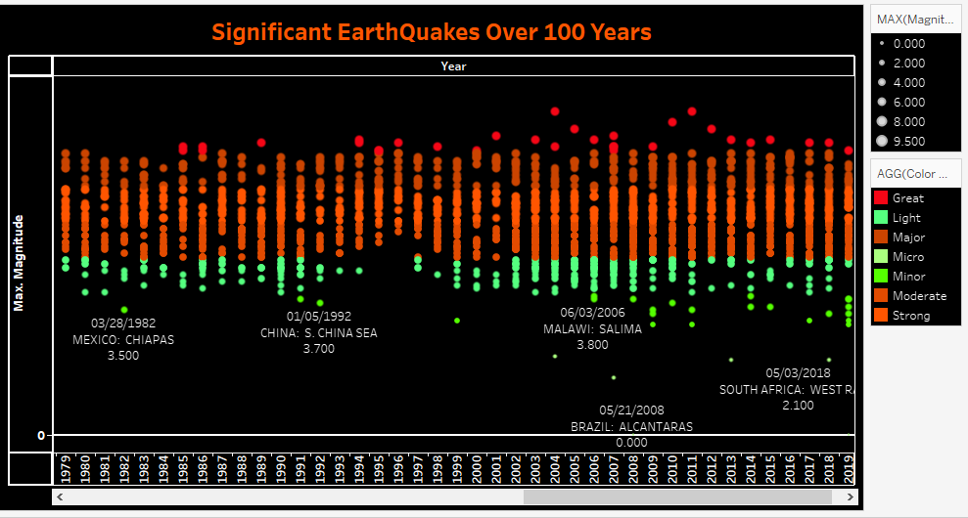

**Insights:**

Insights refer to valuable and meaningful understandings or perceptions gained from analyzing data, information, or experiences. They provide deeper understanding, clarity, or revelation regarding a particular subject or situation.

* The visualization reveals a concentration of high-magnitude earthquakes along the Pacific Ring of Fire, emphasizing the region's heightened seismic activity and the need for robust disaster preparedness measures.
* Analysis of temporal trends shows a notable increase in significant earthquakes in recent decades, highlighting the importance of ongoing monitoring and adaptation of risk mitigation strategies to address evolving seismic hazards.

**Conclusions :**

Conclusions are logical deductions or decisions drawn from observations, evidence, or analysis. Conclusions are often based on the findings or results of a study, experiment, or evaluation, and they aim to summarize key insights or outcomes. Effective conclusions should be supported by evidence, logical reasoning, and critical thinking, leading to well-informed decisions or actions.

* The visualization of significant earthquakes over the past century underscores the importance of leveraging data-driven approaches to understand seismic activity patterns and inform risk mitigation strategies.
* By identifying regions of heightened seismic risk and temporal trends in earthquake occurrence, stakeholders can proactively implement measures to enhance disaster preparedness, infrastructure resilience, and community safety.
* Continued efforts to monitor and analyze seismic data, coupled with proactive planning and investment in resilient infrastructure, are essential for building adaptive capacities and mitigating the impact of earthquakes on human lives, economies, and the environment.